INVENTORY MANAGEMENT SYSTEM
-------------------------------------------------------------------------------

An Computer Programming Project
Presented to the
Faculty of the College of Information Technology
Cagayan de Oro College
Cagayan de Oro City

-------------------------------------------------------------------------------

In Partial Fulfillment
of the Requirements for the Degree
Bachelor of Science in Information Technology

-------------------------------------------------------------------------------

ABDULASES, ARJUNE SANER A.
BACAYANA, CLOYD ALEXIS S.
BERONIO, HEAVEN B.
DAWAL, BRIAN ANGELO
GODES, ALMAR G.
NERI, YANBEL JUDE S.
YAGUEL, LARAH JOY B.

APRIL 10, 2026

1.1 Introduction
In many small stores, store staff are responsible for managing product inventory. This includes checking available stocks, updating product information, restocking items, and ensuring that products are not expired. However, these tasks are commonly done manually using notebooks or simple lists, which can be time-consuming and prone to errors.
Manual inventory management can cause several problems such as stock count errors, difficulty in searching products, and struggle in updating information. It also becomes hard for staff to monitor expiration dates of products, which may result in expired items not being noticed. These issues can lead to disorganized operations and inconvenience in managing the store.
To address these problems, the researchers developed an Inventory Management System. The system is designed to help store staff easily monitor and manage product inventory through a simple and organized platform. It includes functions such as Viewing storage, searching for products, adding and removing items, restocking, and updating product information.
The system is developed as a console-based application, making it simple and easy to use. It focuses on improving accuracy, reducing errors, and helping staff perform their tasks faster and more efficiently.

1.2 Statement of the problem

General Problem
Store staff experience difficulty in managing and tracking product inventory due to manual recording, which often leads to errors, inefficiency, and lack of proper monitoring.
Specific Problems
- Store staff find it difficult to view storage and monitor available products due to unorganized records.
- Searching for products manually takes time, especially when handling many items.
- Updating product information such as name and expiration date can become messy when done manually.
- Restocking and removing products is a struggle, which can cause incorrect stock levels.
- Staff may fail to monitor expiring and expired products, resulting in product waste or losses.

1.3 General objective
The main objective of this study is to develop an Inventory Management System that helps store staff manage, monitor, and update product inventory in a faster and more organized way.

1.4 Specific objectives
- To allow staff to view storage and view all available products.
- To provide a search function to easily find products.
- To enable staff to add and remove products in the system.
- To allow restocking of items and proper updating of stock levels.
- To provide a feature for updating product information such as name and expiration date.
- To help staff monitor expiring and expired products.

Scope & Limitation

1.5 Scope
The Inventory Management System is designed for store staff to manage product inventory using a console-based program.
- The system allows staff to check storage and view product lists.
- The system allows searching for products and checking their details.
- The system allows adding and removing products.
- The system allows for stock level updates.
- The system allows product information updates, such as name and expiration date.
- The system can display expiring and expired products.
- The system provides a simple text-based interface for easy use.

1.6 Limitation
The system can only be used by one staff at a time and does not support multiple users. It also does not include advanced features such as sales tracking, barcode scanning, or online access. The system is intended for small-medium stores only.
- Big Companies
- User Limitation (1)
- Capability Limit(10)
- Advanced Features
- Can’t Add Empty Products

1.7 System Requirements

Hardware Requirements:
- Processor: Intel Core i3 or equivalent.
- Memory (RAM): At least 2 GB.
- Storage: Minimum 100 MB free space
- Monitor: Any text display supporting Gadget.
- Keyboard and Mouse: Required for input.

Software Requirements:
- Operating System: Windows 7 or above.
- Programming Compiler: Java Development Kit (JDK) or above.
- Code Editor (IDE): Visual Studio Code or any IDE.

System Functions
- View Storage
Displays all products and their total quantity.
- Search Product
Allows staff to find a product and view its details.
- Load Product / View Product Stocks
Allows staff to add stock to existing products.
- Unload Product
Allows staff to Unload from existing products.
- Add Product
Allows staff to add new products with a stock to the system.
- Remove Product
Allows staff to remove a product and its contents from the system.
- Update Product Information
Allows updating of product name and expiration date.
- View Expiring Products
Displays products that are about to expire.
- View Expired Products
Displays products that are already expired.
- Exit
Allows the user to return to the main menu or exit the system.

1.8 Flowchart
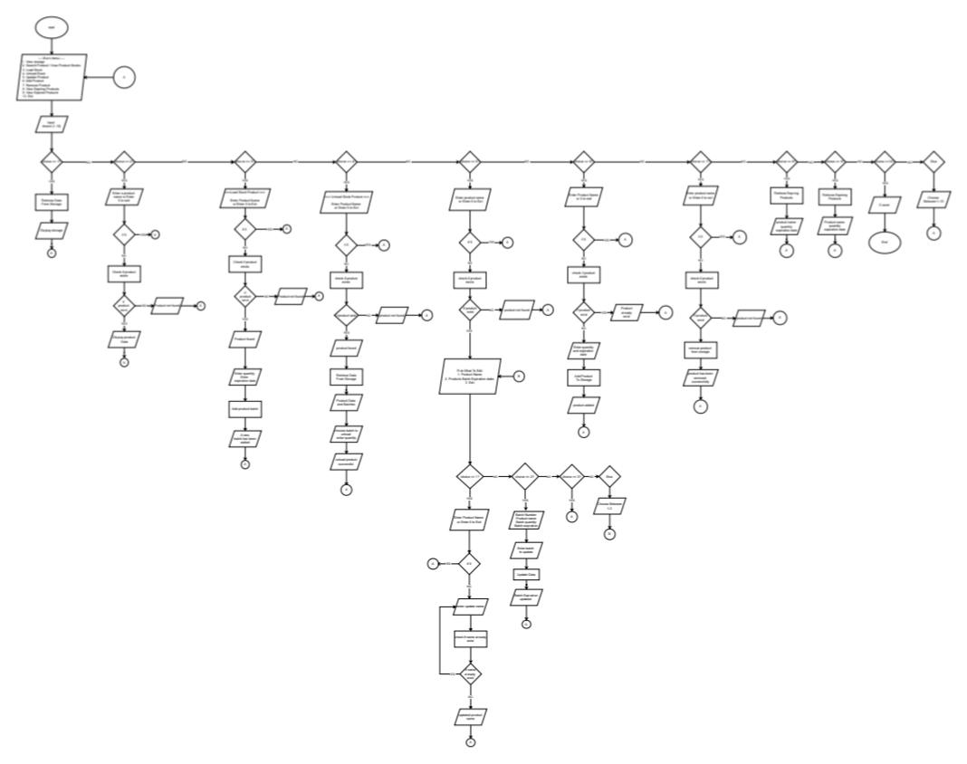

1.9 Code Snippet of Console-Based Inventory System
